**Frequently Asked Questions**

*1. I tried to run the Acq Manager but got an error message – “The program can’t start because mfc100u.dll is missing”. Any ideas?*

This error message typically appears in old version of AcqManager, which requires some dynamic libraries to run. You may need to install a small update from Microsoft Company called “vcredist_64” or “vcredist_32”. We have downloaded it and put it in the same fold of the Acq Manager. You may select the correction version that matches with your windows and install it. By the way, the “mfc100u” indicates it uses Unicode characters, not ASCII or English.

New version of AcqManager (e.g., version 2.3 and later) should not have this problem.

*2. I tried to run the AcqManager, but I got an error message about “ni***.dll” something like that, what is the problem?*

AcqManager supports an increasing list of data acquisition hardwires (or drivers). Currently, many data acquisition hardware (cards) from National Instrument (NI) are supported. To work with the digitization cards from NI, you need the drivers from NI. The program will show error messages if there is no suitable customized hardware components or drivers. You may directly download from the nI website, which is free of charge.

<https://www.ni.com/en-us/support.html>

You may also contact Mecurer LLC or go to the website to download the files.

*3. I would like to do a functional brain research. To that end, I will need to present some figures and sounds while recording MEG/EEG. How can do the work with AcqManager?*

AcqManager supports several ways to link to presentation/stimulation software and hardware. One outstanding software package is BrainX, which is high performance and easy to use. You may use WiFi, parallel port, serial ports and USB port to connect AcqManager and BrainX (or other software). Here is an example for using WiFi to connect AcqManager and BrainX for a functional brain research.

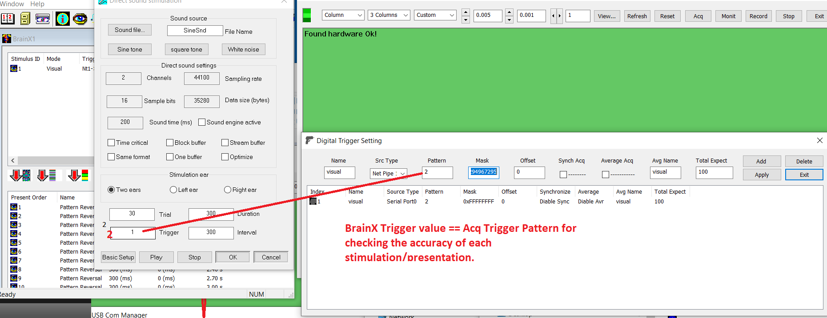

Figure 1. Functional Brain Research with AcqManager and BrainX through WiFi.

*4. I tried to run the AcqManager, but I got an error message about “ni***.dll” something like that, what is the problem?*

AcqManager has the capability to save and re-use the settings of hardware, subjects and other protocols information. For example, you may save all the channel and hardware information for NI-based MEG system. You may re-use the settings at any time. The save and open (reload) of the settings are very easy. Here is the GUI:

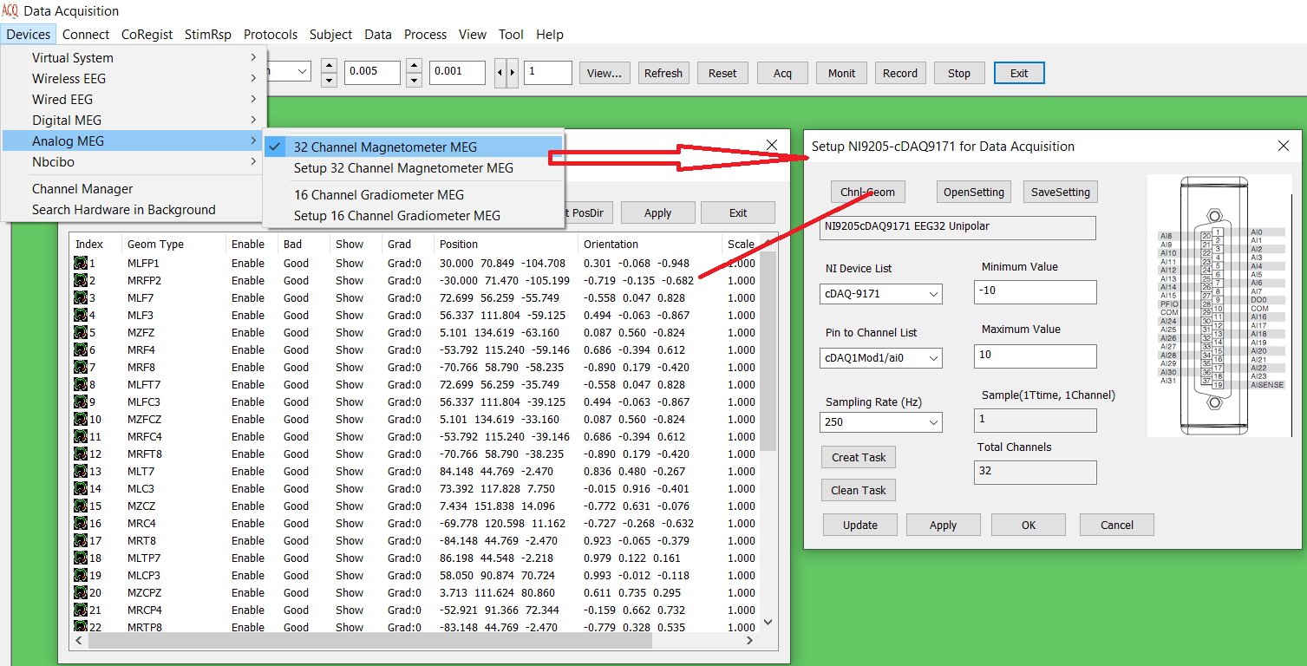

*5. I would like to use the standard “10-20” EEG electrode position for my EEG study. How can I input the position of EEG electrodes?*

AcqManager has the built-in position for you to jump start right away. You do not have to input manually. Here is the example:

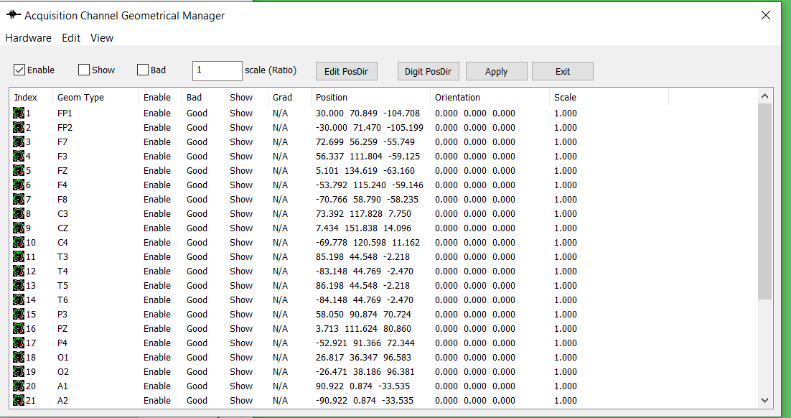

*6. I would like to use the template of MRI. How can I input the position of MEG sensors for a “standard” (or average) head?*

AcqManager has the built-in position for you to jump start right away. You do not have to input manually. Here is the example:

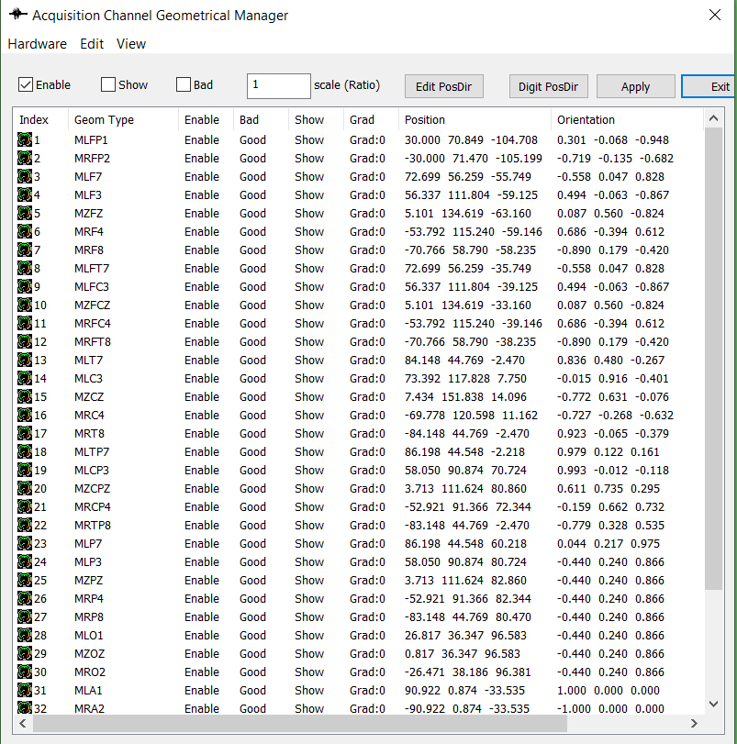

*7. I would like to test new MEG and EEG sensor. To that end, I hope to see the alpha brain activity (8-12 Hz) during data acquisition. Is that possible with AcqManager?*

Yes, AcqManager has the built-in online filter (or run-time filter). You may the change of alpha activity during close eyes in real-time.

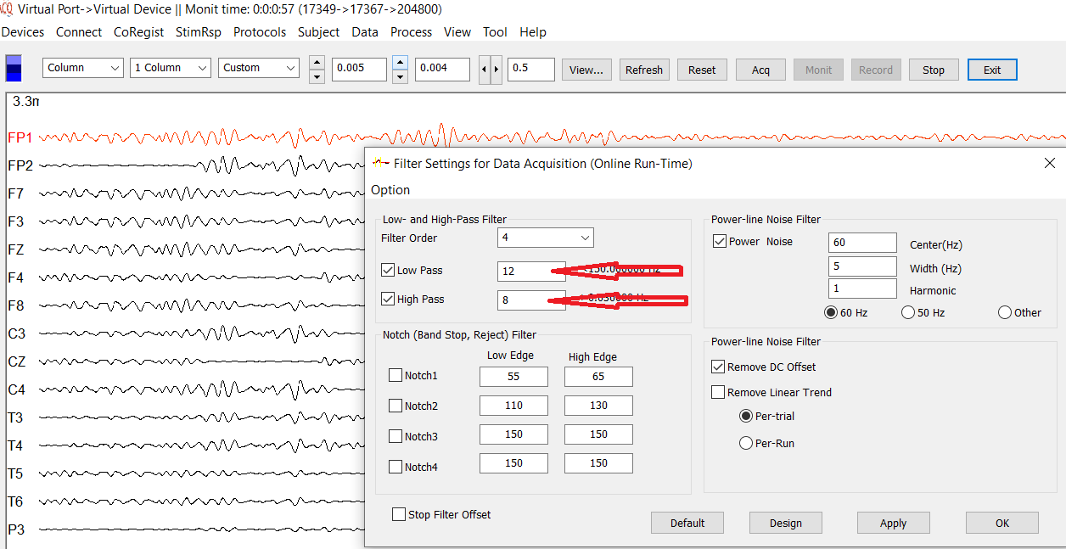

*8. I recorded some nice data from a few subjects. Is there any way to localize the sources?*

Yes, AcqManager is natively supported by a few data analysis software packages, such as MEG Processor, EEG Studio and Magnetic Source Locator (MSL). These software package can analysis the sources and much more, such as time-frequency analyses, network analysis, intelligence detection of epileptic activity. Go beyond the shadow of a doubt, some basic functions, such as averaging, filtering and group analyses, can be easily performed.